**HAZARDOUS AREA MONITORING FOR INDUSTRIAL PLANT**

**POWERED BY IOT.**

# A PROJECT REPORT

***Submitted by***

* **SWETHA K (820619106018)**
* **HEMALATHA M (820619106006)**
* **ARTHI S (820619106002)**
* **VISHNUPRIYA P (820619106019)**

# SANGEETHAPPRIYA (820619106015)

|  |  |
| --- | --- |
| **DEGREE** | **: BACHELOR OF ENGINEERING/TECHNOLOGY** |
| **BRANCH** | **: ELECTRONICS AND COMMUNICATION ENGINEERING** |
| **YEAR OF PASSING** | **: 2023** |
| **COLLEGE** | **:ARASU ENGINEERING COLLEGE** |

**TEAM ID : PNT2022TMID46546**

**TABLE OF CONTENTS**

**CONTENTS PAGE NO**

1. **INTRODUCTION 5**
   1. **Project Overview 5**
   2. **Purpose 5**
2. **LITERATURE SURVEY 5** 
   1. **Exis ng problem 5**
   2. **References 6**
   3. **Problem Statement Defini on 6**
3. **IDEATION & PROPOSED SOLUTION 6**
   1. **Empathy Map Canvas 6**
   2. **Idea on & Brainstorming 73.3 Proposed Solu on**  8

**3.4** Problem Solution fit 8

1. **REQUIREMENT ANALYSIS 8**
   1. Functional requirements 8
   2. Non-Functional requirements 8
2. **PROJECT DESIGN 9**
   1. Data Flow Diagrams 9
   2. Solution & Technical Architecture 9
   3. User Stories 10
3. **PROJECT PLANNING & SCHEDULING 10**
   1. Sprint Planning & Estimation 10
   2. Sprint Delivery Schedule 11
   3. Reports from JIRA 11
4. **CODING & SOLUTIONING**

**(Explain the features added in the project along with code) 11**

* 1. Feature 1 11
  2. Feature 2 21
  3. Database Schema (if Applicable) 22

1. **TESTING 22**
   1. Test Cases 22
   2. User Acceptance Testing 22
2. **RESULTS 22** 
   1. Performance Metrics 22
3. **ADVANTAGES & DISADVANTAGES 23**
4. **CONCLUSION 24**
5. **FUTURE SCOPE 24 13. APPENDIX 24**

Source Code 24

GitHub & Project Demo Link 27

# 1.INTRODUCTION

1.1 Project Overview

To monitor the temperature parameters of the hazardous areas in industrial plants. The area is integrated with smart beacon devices every employees working there will be given smartwearable device.

With beacon scanners the employees can view the temperature on his smart wearable device and if the temperature is high, they will receive the alerts to the mobile through SMS, the information is sent to the cloud and through that, the in-charge of that particular plant can view the data and take safety precautions priorly.

1.2 Purpose

For safety purpose it is used in the industry areas since any descripancies may happen anytime but prior safety alert has to be given by monitoring the area. Surveillance is a major issue in public restricted areas. The robot is hired here to monitor throughout the day, his robotic vehicle has ability to substitute the human in hazardous area to provide surveillance for the betterment of the industry these are installed and maintained for the industry purpose. They keep a check of all the things to be delivered at the ease without any problems.

## 2. LITERATURE SURVEY

2.1Existing problem

Working in radiated and harmful environment and become chronic to various diseases and this could be avoided by the development in the industry like installing monitoring systems. Hazardous classified locations are areas where the possibility of fire or explosion hazards may exist under normal or abnormal conditions because of the presence of flammable, combustible or ignitable gases, vapors, liquids, dust, or fibersDetermining the class, division and group and a particular group is criticalto correctly applyingthe requirements for a givenhazardous locality.

2.2 References

IEEE Papers:

i. [*2022InternationalConferenceonElectronicsandRenewableSystems(ICEARS)*](https://ieeexplore.ieee.org/xpl/conhome/9751779/proceeding)ii. [*2020InternationalConferenceon*](https://ieeexplore.ieee.org/xpl/conhome/9177229/proceeding)

[*CommunicationandSignalProcessing*](https://ieeexplore.ieee.org/xpl/conhome/9177229/proceeding)

[*(ICCSP)*](https://ieeexplore.ieee.org/xpl/conhome/9177229/proceeding)iii. [*20166thInternationalConferenceonSystemEngineeringand*](https://ieeexplore.ieee.org/xpl/conhome/7838016/proceeding)

[*Technology(ICSET)*](https://ieeexplore.ieee.org/xpl/conhome/7838016/proceeding)

Reference Links:

* 1. *http://159.122.174.217:31458/-Nodered*
  2. *http://159.122.174.217:31458/sensor-Sensing URL*
  3. *http://159.122.174.217:31458/ui/#!/0?socke tid=Umm7oFpqvrobz5EaAACY- Web UI*
  4. *http://159.122.174.217:31458/control- Control*

*Command*

2.3 Problem Statement Definition

Employees working in the industry, nearby office and resident people can be safe guarded by the precautions that can be taken in the industry. How significant it is and why does it matter compared to otherways are being analyzed.

1. IDEATION & PROPOSED SOLUTION

3.1 Empathy Map Canvas

It Creates an effective solutionrequires understanding the true problem and the person who is experiencing it. The exercise of creating the map helps participants consider things from the user’s perspective along with their goals and challenges.

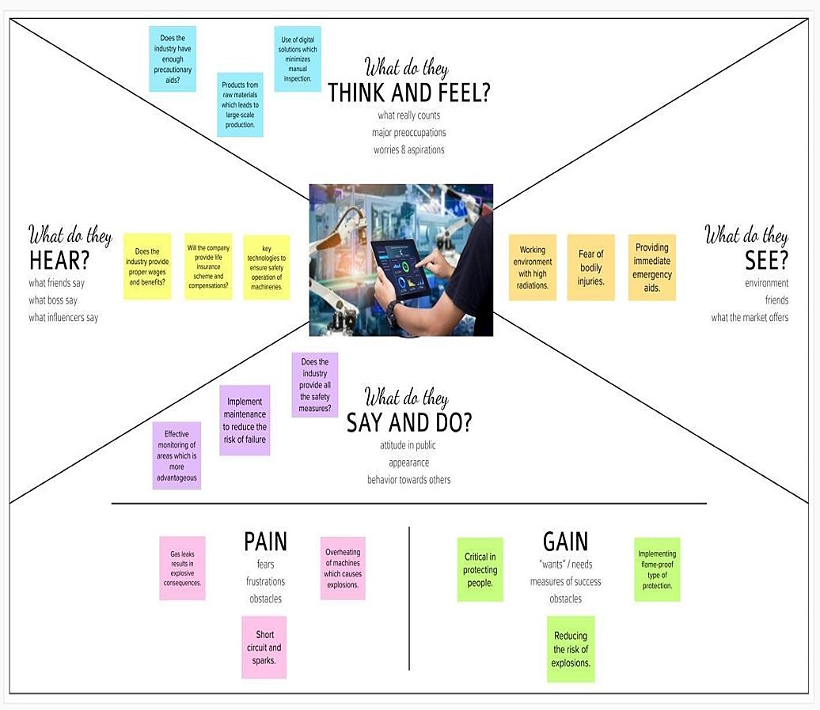

3.2Ideation & Brainstorming

Brainstorming techniques are proven frameworks for coming up with lots of ideas quickly Establishing an ideation mindset and encouraging creative thinking will benefit your organization in the long term, and findingnew ways to push your team in the directionof generating effective ideas has positive effects for your whole organization. Smart sensors for hazardous areas monitor key parameters of assets such as motors and pumps and provide detailed insights into their performance and health.

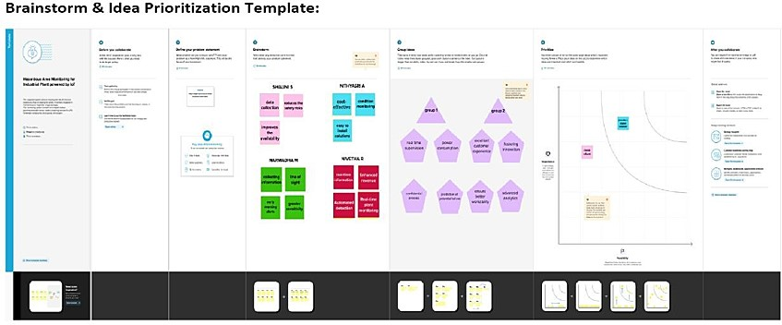

* 1. Proposed Solution

Many advancements such as augmentedreality, automatic identification, indication and many new technologies. Prewarning systems has been integerated so based on these the newly proposed the required solution can be verified effectively. Leading global technology company that energizes the transformation of society and industry to achieve a more productive, sustainable future. By connecting software to its electrification, robotics, automation and motion portfolio, ABB pushes the boundaries of technology to drive performance to new levels.

* 1. Problem Solutionfit

Customers constriants, Segments,behaviour problem root cause, solutionto the problems are given based on the solutionfit that has to be given for the proper monitoring.

4.REQUIREMENT ANALYSIS

* 1. Functional requirement

User registration, verification, authentication and notification has been given based on the needs of the requirements of the industrial area.

* 1. Non-Functional requirements

Performance, usability, security has to be assured based on these requirements the way of using the resource can be accomplished.

## 5. PROJECT DESIGN

5.1 Data Flow Diagrams

Basic representation of the system flow is followed,

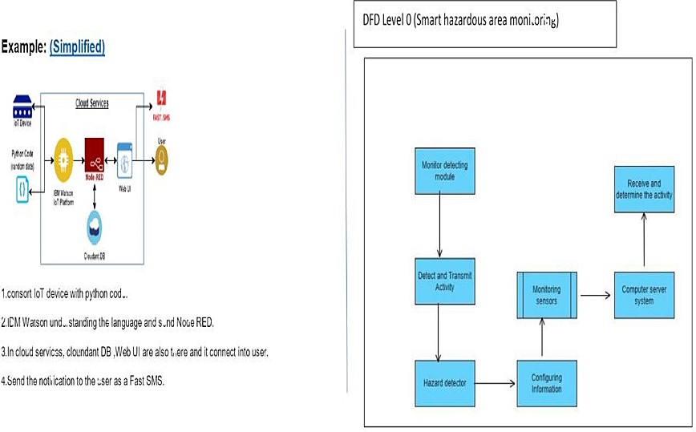

5.2Solution & Technical Architecture

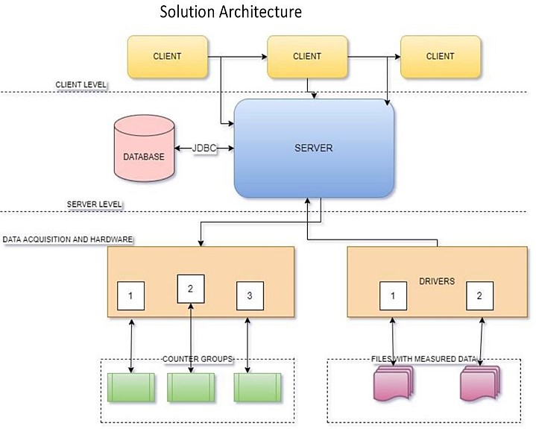

5.3 User Stories

All the customersneeds are given based on the requirements that are necessarily available and building up the right architecture needed. The robot is hired here to monitor throughout the day. This robotic vehicle has ability to substitute the human in hazardous area to provide surveillance.

## 6. PROJECT PLANNING& SCHEDULING

6.1 Sprint Planning & Estimation

Creation of Watson IOT, Node-Red and the MIT app inventor are being proposed for the delivery if the sprints it is totally based on the system administration that has to take place in the estimation of the sprint is given by the output obtained.

6.2 Sprint Delivery Schedule

Sprints are given by the proper scheduling with the requiredanalysis that couldbe done for themonitoring of the temperature and humidity.

6.3 Reports from JIRA

This represents the solutions given from the sprints.

## 7. CODING & SOLUTIONING

7.1 Feature 1

From Node red HTTP link has been created and this is used in MIT app for the creation and the used code is given below,

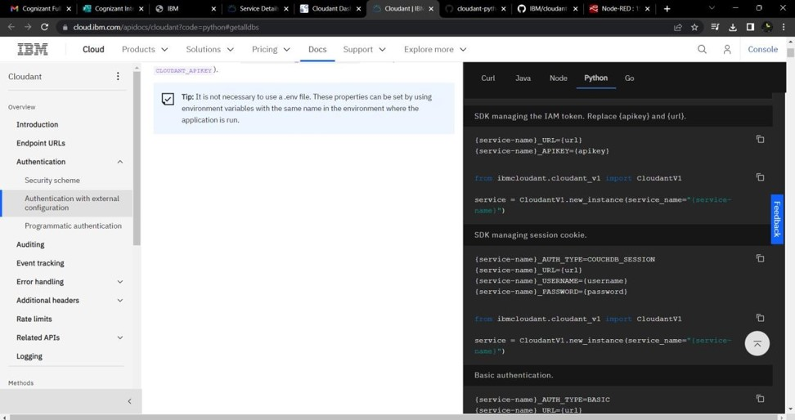

**Creating device in the IBM Watson IoT platform.**

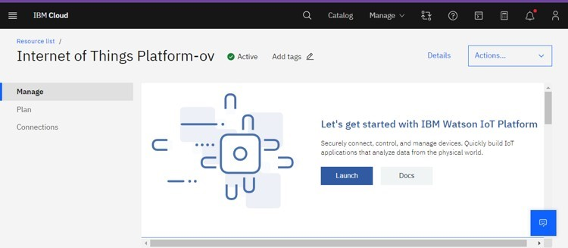

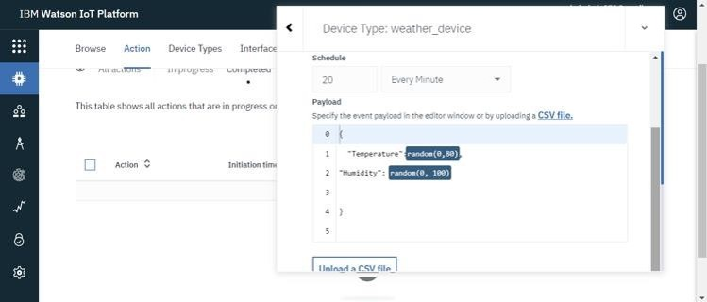

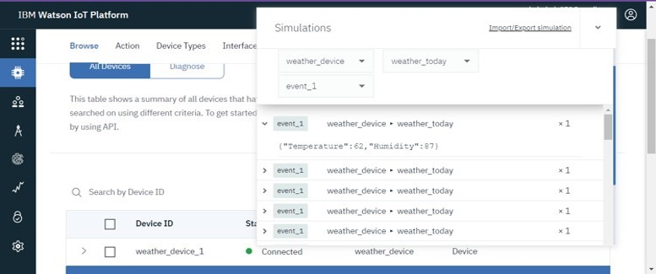

**Displaying charts for temperature and humidity values fetched from weather_monitoring device created in IBM Watson IoT platform.**

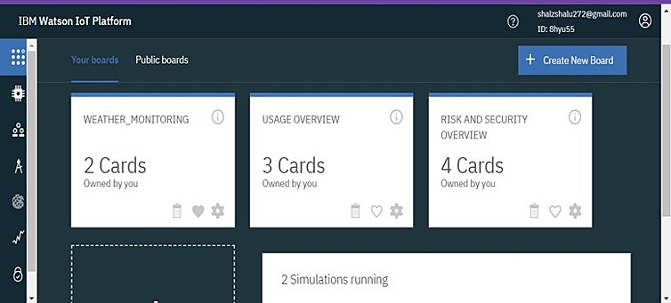

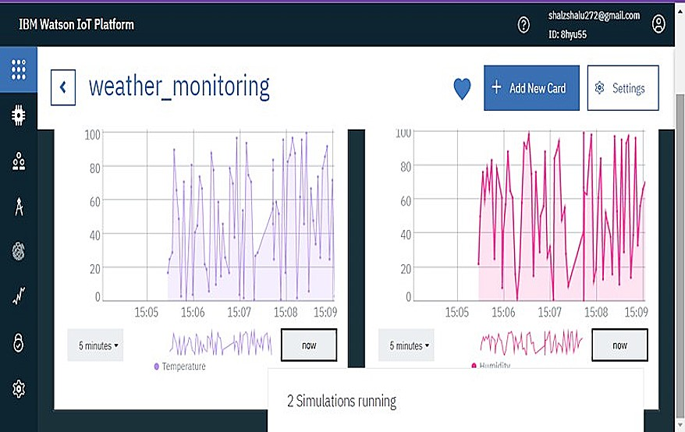

**Unique API and authentication key generated from IBM Watson IoT platform for the weather montoring device ( here, Device name : weather_monitoring ) is used to connect the device created in IoTplatform**

**(IBM clou) to Node-RED workflow.**

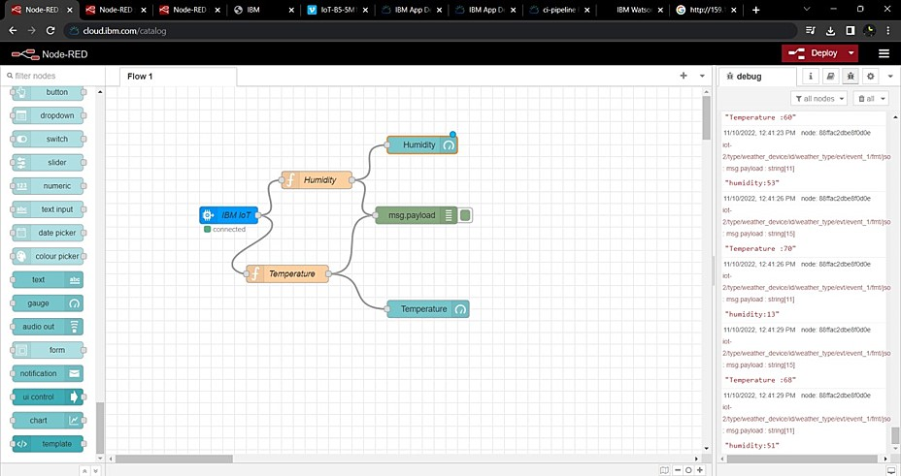

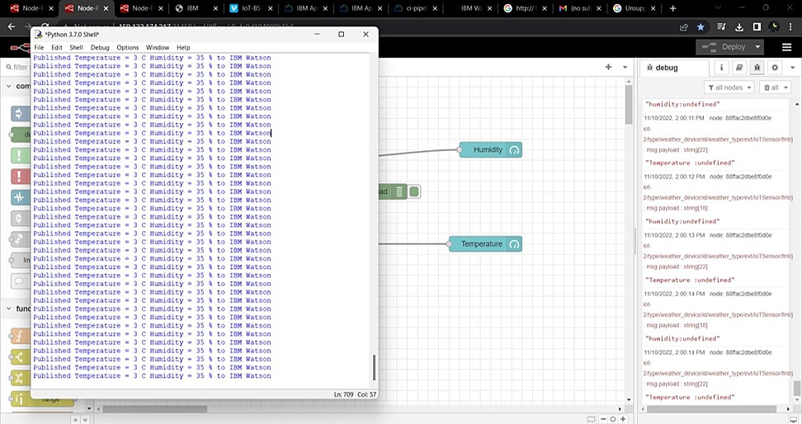

**Unique device credentials for the weather_monitoring device created in IoT platform is dumped into python code and Internal device simulator is ON for the same device to fetch parameters like temperature and humidity when node flow is deployed.**

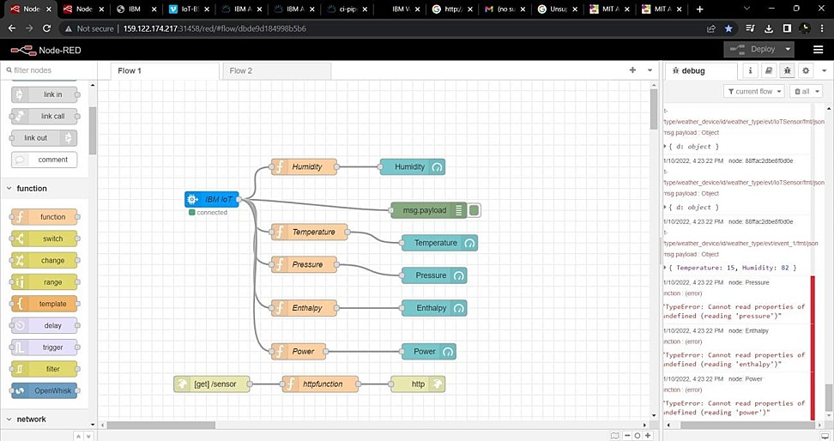

**Creating dashboard for the work flow scenario created in Node-RED.**

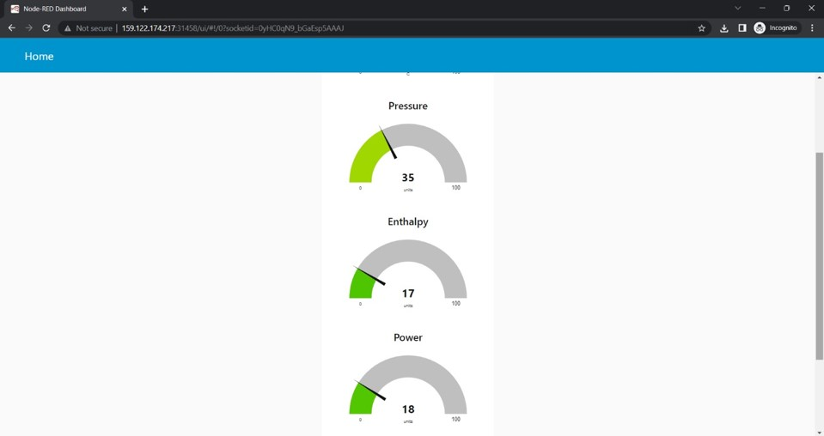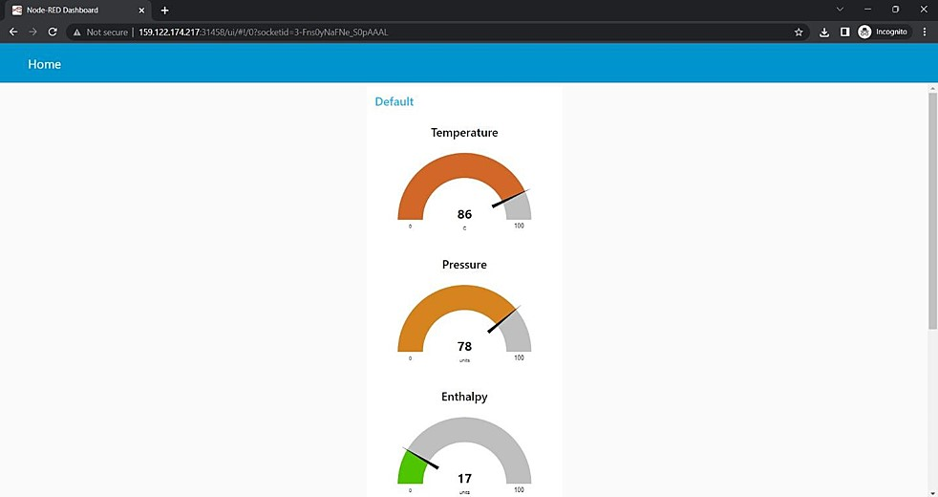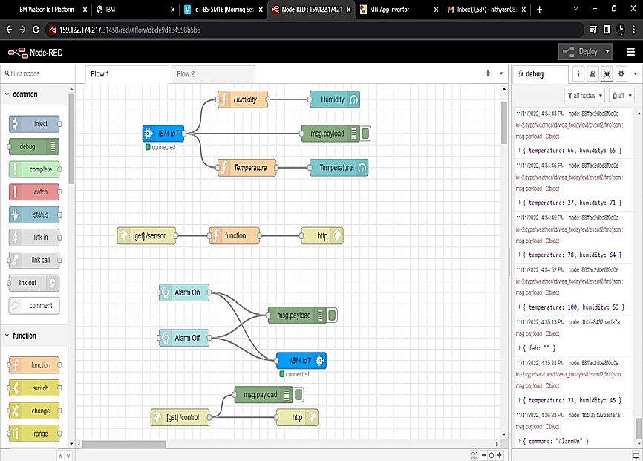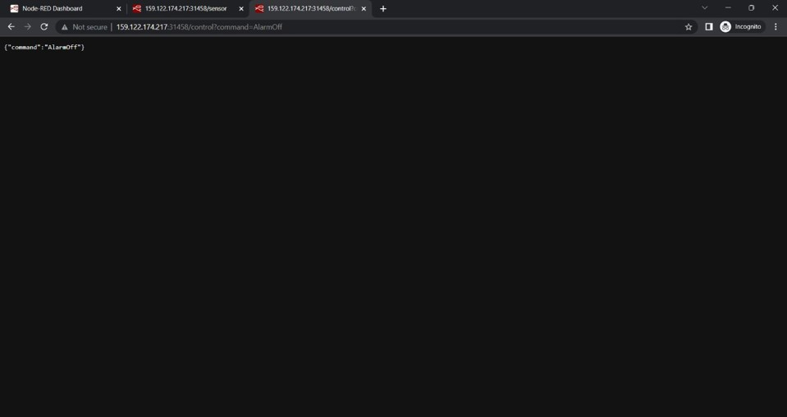

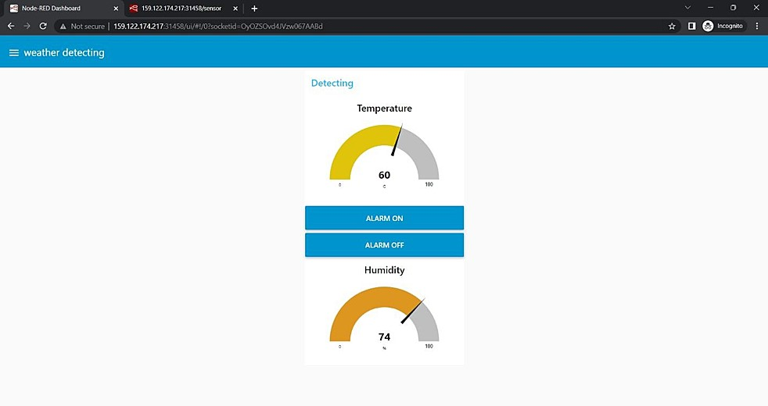

**Alarm will be ON if temperature reaches critical point and OFF when in acceptable level.**

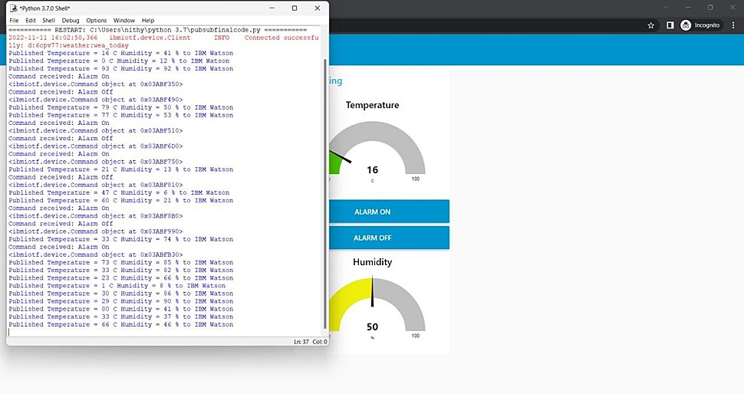

**Creating a node flow for getting http(URL) , using http in and response nodes.**

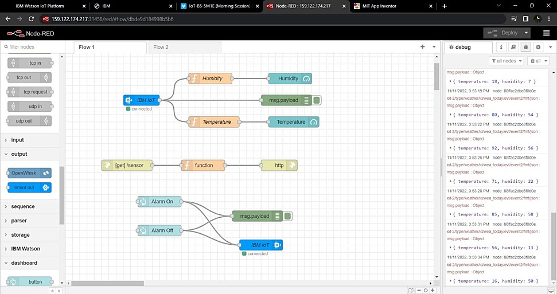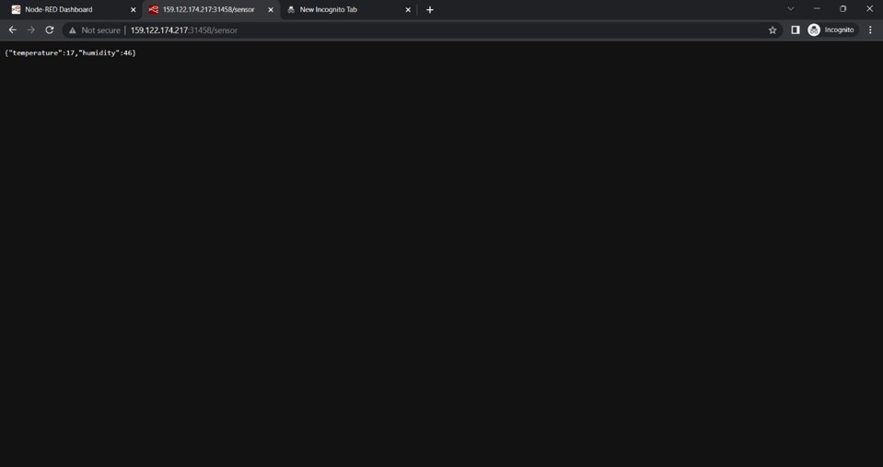

**Building block codes for deploying hazardous area monitoring app.**

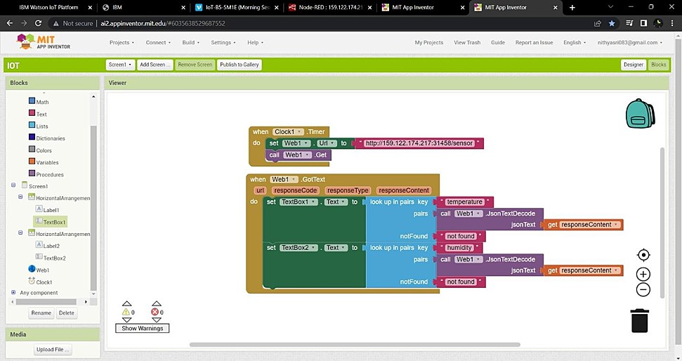

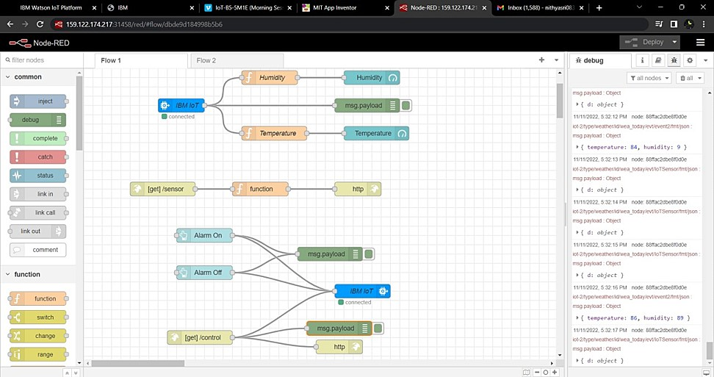

**Using GET function in block codes which allow us to request http (URL) of Node-RED workflow and a clock timer ( 1 sec ) is set to get reading or information on temperature and humidity of industrial plant at remote location for every second sequentially.**

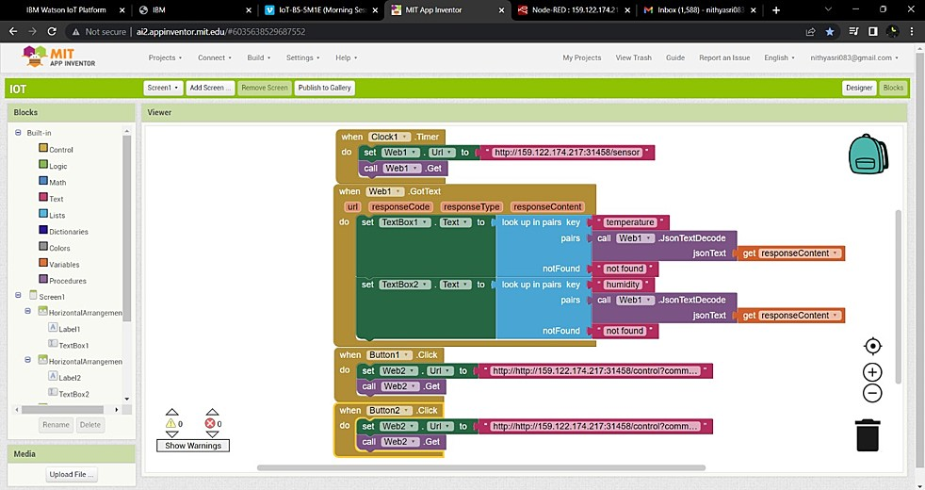

**App is deployed for monitoring industrial plant with alarm ON and OFF features thus avoiding certain unexpected accidents industrial plants.**

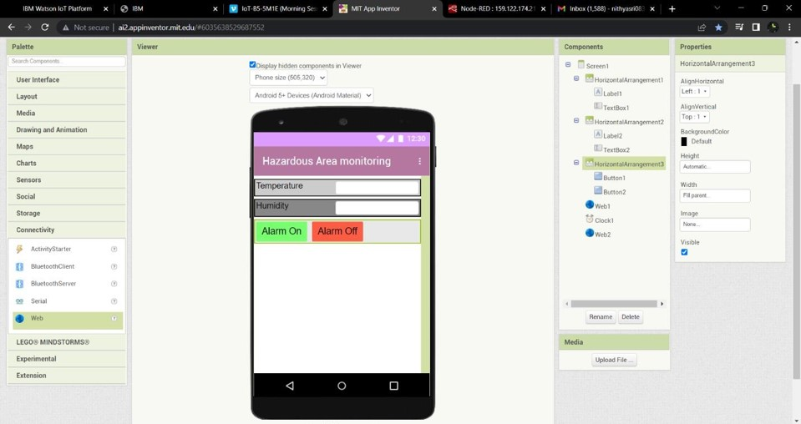

7.2 Feature 2

Temperature and Humidity is being measured using the final code given in the MIT application

7.3 Database Schema (if Applicable)

HTTP link generated from node red is being taken so this is the only database that has been taken since HTTP link createdin the node red is being obtainedfor the MIT application for the sensing of temperature and humidity.

CLOUDANT

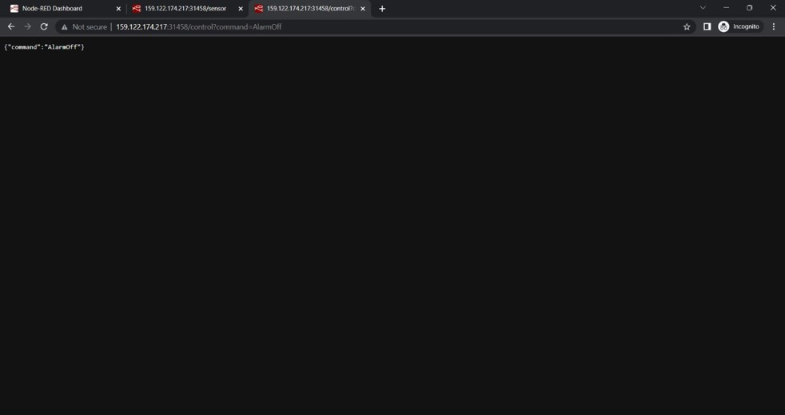

## 8 TESTING

8.1 Test Cases

The main test case is to deliver the Temperature and Humidity of the hazardous area if there is an increase in temperature there would be an alert messagethrough which we can take safety measures priorly.

8.2 User Acceptance Testing

To input the code based on the accepteduser input is being testedfor the purposeof obtaining the desired output.

## 9. RESULTS

9.1 PerformanceMetrics

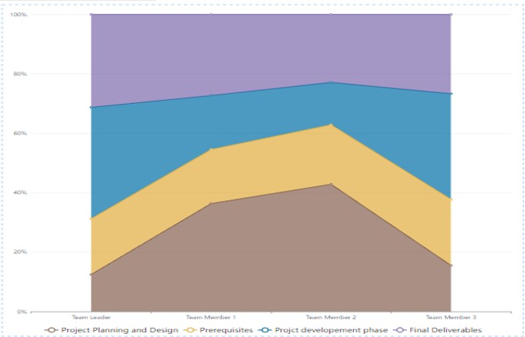

## 10. ADVANTAGES & DISADVANTAGES

ADVANTAGES:

1. Constant measurement of relative temperature and humidity is done so that there are no discrepancies.
2. Information of power andenergy consumption is lessened upto 10%.

DISADVANTAGES:

1. Smart sensors for hazardous areas monitor are the key parameters if these face any problemthere would be a major failure in the whole monitoring system.
2. Accessing immediately to the hazardous areas is difficult hence it is costly and time- consuming to monitor the condition and their performance.

11. CONCLUSION

The hazardous area is beingmonitored using the temperature and humidity sensors.

## 12. FUTURE SCOPE

1. Safety precautions are relatively more than the usual monitoring system.
2. The way of using these without manual input can be upgradedeven more for the betterment than these technologies used in our generation. 3. Safety of the employees in the industrial plant is the most important so these systems can make them more secured.

## 13. APPENDIX

Source Code

import timeimport sys

import ibmiotf.applicationimport ibmiotf.deviceimport random

#Provide your IBM Watson Device Credentialsorganization = "6cpv77"deviceType = "weather"deviceId = "wea_today"authMethod = "token"authToken = "Fo9af9o00doS8VUsb2"

# Initialize GPIO

def myCommandCallback(cmd):

print("Command received: %s" % cmd.data['command'])

status=cmd.data['command']

if status=="Alarm On":

print("Alarm is off")

else:

print("Alarm is On")

#print(cmd)

try:

deviceOptions = {"org": organization, "type": deviceType, "id": deviceId, "auth-method":

authMethod, "auth-token": authToken}deviceCli = ibmiotf.device.Client(deviceOptions)

#..............................................

except Exception as e:print("Caught exception connecting device: %s" % str(e))sys.exit()

# Connect and send a datapoint "hello" with value "world" into the cloud as an event of type

"greeting" 10 timesdeviceCli.connect()while True:

#Get Sensor Data from DHT11

temp=random.randint(0,200)

humidity=random.randint(0,200)

if temp>=100:

print("Alert")

else:

print("safe")

data = {"d":{ 'temp' : temp, 'humidity': humidity}}

#print data

def myOnPublishCallback():

print ("Published Temperature = %s C" % temp, "Humidity = %s %%" % humidity, "to IBM Watson")

success = deviceCli.publishEvent("IoTSensor", "json", data, qos=0, on_publish=myOnPublishCallback)

if not success:

print("Not connected to IoTF")

time.sleep(1)

deviceCli.commandCallback = myCommandCallback

# Disconnect the device and application from the clouddeviceCli.disconnect()

# GitHub & Project Demo Link

**PROJECT SIMULATION DEMO LINK:**

[https://drive.google.com/file/d/1GH9_yOBIlerSep5ax4MNTg6fA03R26Oi/view?u sp=share_link](https://drive.google.com/file/d/1GH9_yOBIlerSep5ax4MNTg6fA03R26Oi/view?usp=share_link)

**GITHUB:**

[**https://github.com/IBM-EPBL/IBM-Project-3920-1658671809**](https://github.com/IBM-EPBL/IBM-Project-3920-1658671809)